Senate File: SR-5
Date Introduced: 10/31/2016
Introduced by: Public Relations and Elections Committee

A Resolution:

WHEREAS: Nebraska Wesleyan University is an academic community dedicated to intellectual and personal growth within the context of a liberal arts education; and,

WHEREAS: The Student Affairs Senate is the formal governing body for students that creates legislation to improve student life; and,

WHEREAS: Campus involvement in Student Affairs Senate funded activities needs improvement; and,

WHEREAS: In order to provide this improvement for Student Affairs Senate, the Public Relations and Elections Committee is requesting funds for the 2016-2017 school year in order to provide T-Shirts for the Student Affairs Senate. Therefore:

BE IT RESOLVED BY THE 2016-2017 STUDENT AFFAIRS SENATE THAT:

SAS allocates up to $700.00 to the Public Relations and Elections Committee for the Student
Affairs Senate T-Shirts.

See cost breakdown and design below.
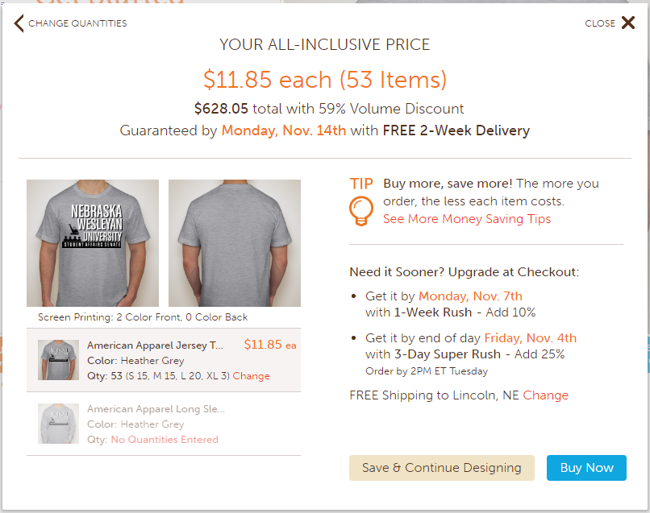

Floor Action: ___Passes_________________________________________________________

Vote Count: __38__Ayes__0__Nays__0__Absentions

Vice President: ____________________________

Presidential Action: _____Approve_____Veto

President: ________________________________

