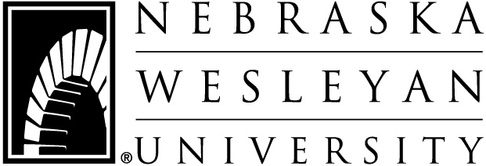
DATE: 2018-2019
TO: Parent(s) of NWU Student
FROM: Katrina Rademacher, Assistant Direct of Financial Aid – Loan Specialist
SUBJ: Federal Parent Loan for Undergraduate Students (PLUS)

The Federal Direct PLUS offers an affordable option for parents to assist their dependent student with the costs of tuition, fees, room, board, books and miscellaneous expenses. The amount borrowed using the PLUS loan may include the yearly cost of an undergraduate education less financial aid (scholarships, grants, loans, and outside scholarships). Eligibility is not based on financial need; it is determined by a federal credit check approval. There is a federal loan origination fee of 4.264% that will reduce the requested amount. However, you may increase the loan amount to cover the fees. The loan disbursements will be sent to Nebraska Wesleyan in two equal installments (half each semester). Interest begins accruing at 7.595% when the money is applied to the student’s school account. Payment on the PLUS loan begins either 60 days after the loan is fully disbursed or you may request through your servicer to wait until six months after the dependent student, on whose behalf the parent borrowed, ceases to be enrolled on at least a half-time basis or graduates. For more information about borrowing limits, repayment plans and interest rates, go to https://studentaid.ed.gov/sa/types/loans/plus.

To apply for the Federal Direct PLUS Loan go to https://studentloans.gov, click on “log in,” enter one parent’s/stepparent’s FSA ID username and FSA ID password. If the parent/stepparent borrower does not have a FSA ID username and password yet, click on the link “Create an FSA ID.” Once you are logged into the studentloans.gov website, click on “Complete Master Promissory Note” and then under “select the type of loan you would like to receive,” click on Parent PLUS. You are now ready to complete and submit the PLUS Master Promissory Note (MPN). You may also complete the PLUS Loan application on this website if you choose to not complete our attached paper application, if you choose this option please make sure to include a dollar amount online that you wish to receive. Our office will be notified once you have completed this process. This notification must be received before we can process your PLUS for the amount you wish to borrow.

ADDITIONAL INFORMATION:
- Make certain the borrower’s and student’s social security number and date of birth are correct
- If parents are separated/divorced, each parent may complete an MPN for same student
- Eligible non-citizens must provide documentation to our office. Acceptable documentation is the Alien Registration Card (I-551 or I-151) or the Arrival-Departure Record (I-94). Provide a copy of the front and back of the card
- Room and board charges for residential halls, suites, townhouses and university owned apartments are on back of this sheet.
- If you know your credit rating is poor, contact our office, krademac@nebrwesleyan.edu, and request an application for PLUS pre-approval prior to completing the MPN online. It can be faxed or e-mailed if you provide us with that information.
- Be sure to return to NWU’S Financial Aid Office the enclosed PLUS Application Form if you choose to not complete the application online. It must be completed entirely, including an exact dollar amount in #6.
- Our address: Office of Scholarships and Financial Aid, 5000 St. Paul Ave, Lincoln, NE 68504
- Fax number: (402) 465-2177 E-mail: jld@nebrwesleyan.edu or krademac@nebrwesleyan.edu

